**CATARACT DETECTION AND GRADING USING DEEP CONVOLUTIONAL NEURAL NETWORK (DCNN)**

**ABSTRACT:**

Cataract is one of the most prevalent causes of blindness in the modern society, accounting for 50% of blindness. According to a survey done by WHO/NPCB there is a backlog of over 22 million blind eyes (12 million blind people) in India. 80.1% of those are blind as a result of cataract. The annual rate of cataract blindness is about 3.8 million. Early detection and treatment can reduce the suffering and prevent visual impairment from turning into blindness. But the expertise needed for early detection and grading is down to the availability of expert trained eye specialist which may not be available in rural parts of the country. Existing studies on automatic detection and grading based on fundus images utilizes a predefined set of images provide which may be incomplete or the images may be noisy and hence render the images ineffective.

In this project, the aim is to use Deep Convolutional Neural Network (DCNN) to detect and grade cataract automatically. This will help in early detection of cataract even without the presence of a trained eye specialist in some of the remote parts of the country.

**REFERENCES:**

1. Linglin Zhang et al., "Automatic cataract detection and grading using Deep Convolutional Neural Network," 2017 IEEE 14th International Conference on Networking, Sensing and Control (ICNSC), 2017
2. Y. Dong, Q. Zhang, Z. Qiao and J. Yang, "Classification of cataract fundus image based on deep learning," 2017 IEEE International Conference on Imaging Systems and Techniques (IST), 2017, pp. 1-5, doi: 10.1109/IST.2017.8261463.
3. X. Gao, S. Lin and T. Y. Wong, "Automatic Feature Learning to Grade Nuclear Cataracts Based on Deep Learning," in IEEE Transactions on Biomedical Engineering, vol. 62, no. 11, pp. 2693-2701, Nov. 2015, doi: 10.1109/TBME.2015.2444389.
4. M. S. Mahmud Khan, M. Ahmed, R. Z. Rasel and M. Monirujjaman Khan, "Cataract Detection Using Convolutional Neural Network with VGG-19 Model," 2021 IEEE World AI IoT Congress (AIIoT), 2021, pp. 0209-0212, doi: 10.1109/AIIoT52608.2021.9454244.
5. M. S. Junayed, M. B. Islam, A. Sadeghzadeh and S. Rahman, "CataractNet: An Automated Cataract Detection System Using Deep Learning for Fundus Images," in IEEE Access, vol. 9, pp. 128799-128808, 2021, doi: 10.1109/ACCESS.2021.3112938.
6. Goh, Jocelyn Hui Lin; Lim, Zhi Wei BSc (Hons); Fang, Xiaoling MD; Anees, Ayesha MSc; Nusinovici, Simon PhD∗; Rim, Tyler Hyungtaek MD, PhD; Cheng, Ching-Yu MD, PhD; Tham, Yih-Chung PhD, Artificial Intelligence for Cataract Detection and Management, Asia-Pacific Journal of Ophthalmology: March-April 2020 - Volume 9 - Issue 2 - p 88-95 doi: 10.1097/01.APO.0000656988.16221.04

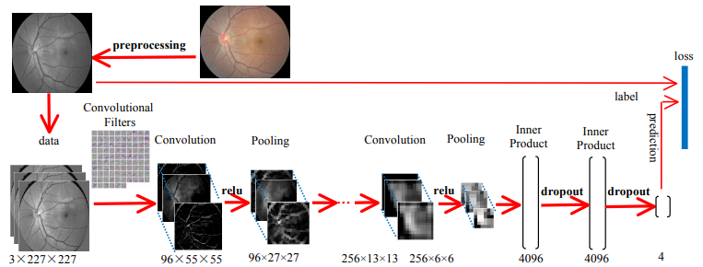

**Figure 1: Process Flow**

**CONCISE ABSTRACT:**

Cataract is the lead cause of blindness in the country and worldwide accounting for 80.1% in India and 50% around the world. Early detection and treatment can help in bring the numbers down by a significant margin of cases of blindness due to cataract but the lack of trained expert (Ophthalmologists) in remote locations makes it difficult to detect and treat cataract an early stage.

Using Deep Convolutional Neural Network to create an automated detection and grading model would help in the process of early detection at the earliest of stages possible and as a result the treatment can be started soon as well. The system would detect cataract from the slit lamp images and then grade it according to its severity which without the intervention of a trained specialist is not possible in the outside world yet.

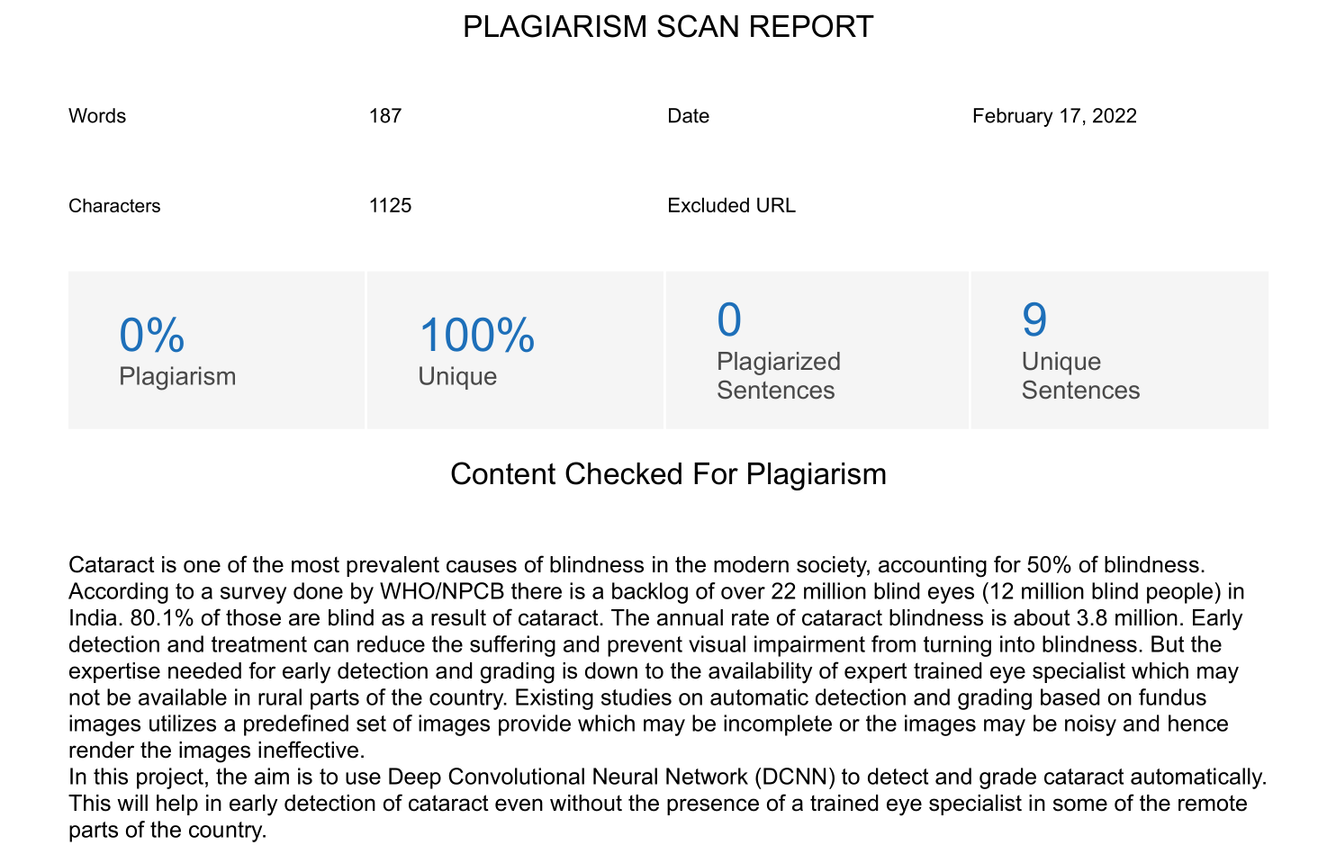

**Source:** https://smallseotools.com/plagiarism-checker/

**RESEARCH JOURNALS:**

1. Automatic cataract detection and grading using Deep Convolutional Neural Network. (<https://ieeexplore.ieee.org/abstract/document/8000068>)
2. Classification of cataract fundus image based on deep learning. (<https://ieeexplore.ieee.org/abstract/document/8261463>)
3. Automatic Feature Learning to Grade Nuclear Cataracts Based on Deep Learning. (<https://ieeexplore.ieee.org/abstract/document/7122265>)
4. Artificial Intelligence for Cataract Detection and Management. (<https://journals.lww.com/apjoo/fulltext/2020/04000/artificial_intelligence_for_cataract_detection_and.6.aspx>)
5. Cataract Detection Using Convolutional Neural Network with VGG-19 Model. (<https://ieeexplore.ieee.org/abstract/document/9454244>)
6. CataractNet: An Automated Cataract Detection System Using Deep Learning for Fundus Images. (<https://ieeexplore.ieee.org/abstract/document/9539231>)